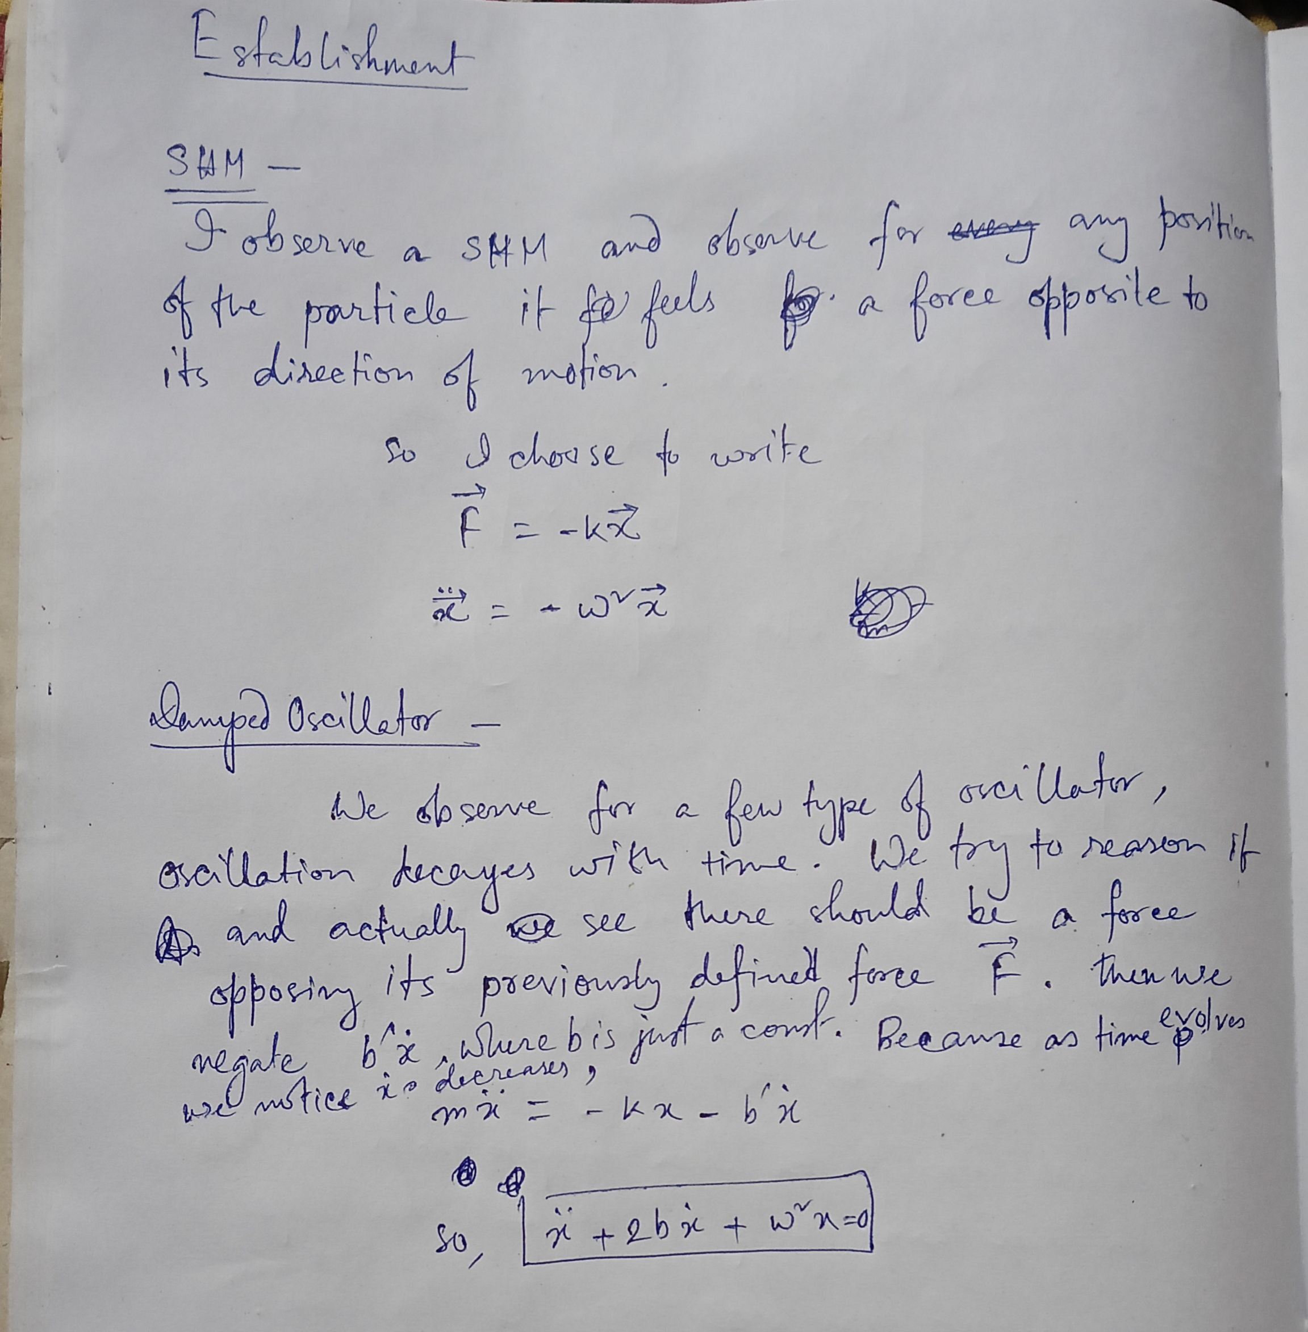

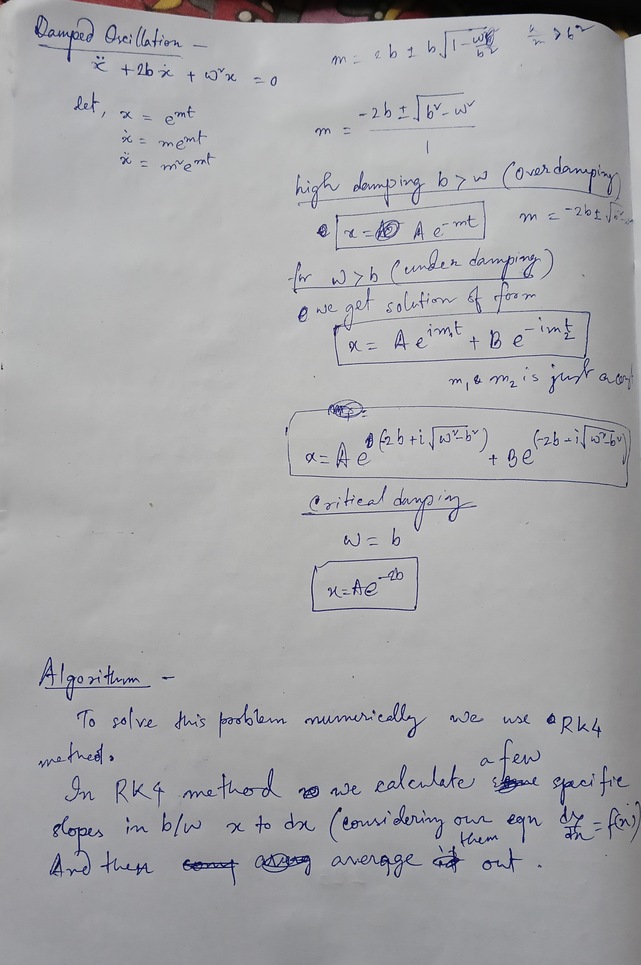
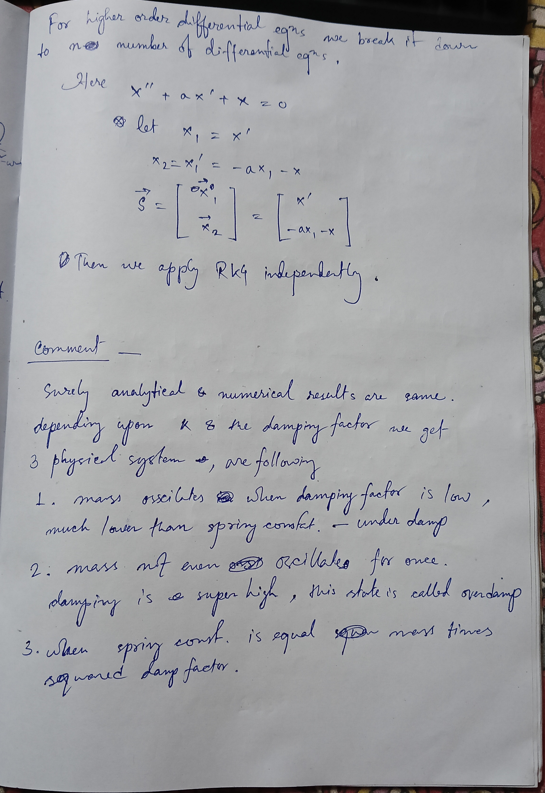

PROGRAM DampedOscillationAnalytic
IMPLICIT NONE

REAL :: t, x, v
REAL :: m, b_, b, k, omega0, omegad
REAL :: x0, v0
REAL :: r1, r2, C1, C2
REAL :: dt, t_max
INTEGER :: i, n

OPEN(1, FILE="underdamped.dat", STATUS="REPLACE")
OPEN(2, FILE="overdamped.dat", STATUS="REPLACE")
OPEN(3, FILE="criticaldamped.dat", STATUS="REPLACE")

PRINT *, "Enter m, b_, k, x0, v0 :"
READ(*,*) m, b_, k, x0, v0

b = b_ / (2.0*m)
omega0 = SQRT(k/m)

dt = 0.01
t_max = 20.0
n = INT(t_max/dt)

IF (b < omega0) THEN
! -------- UNDERDAMPED --------
omegad = SQRT(omega0*omega0 - b*b)

DO i = 1, n
t = i * dt

x = EXP(-b*t) * ( x0*COS(omegad*t) + &
(v0 + b*x0)/omegad * SIN(omegad*t) )

v = EXP(-b*t) * ( -b*x0*COS(omegad*t) - &
(b*(v0 + b*x0)/omegad)*SIN(omegad*t) - &
x0*omegad*SIN(omegad*t) + &
(v0 + b*x0)*COS(omegad*t) )

WRITE(1,'(F10.4,1X,F10.4,1X,F10.4)') t, x, v
END DO

ELSE IF (ABS(b - omega0) < 1.0E-6) THEN
! -------- CRITICALLY DAMPED --------
DO i = 1, n
t = i * dt

x = EXP(-b*t) * ( x0 + (v0 + b*x0)*t )
v = EXP(-b*t) * ( v0 - b*(v0 + b*x0)*t )

WRITE(3,'(F10.4,1X,F10.4,1X,F10.4)') t, x, v
END DO

ELSE
! -------- OVERDAMPED --------
r1 = -b + SQRT(b*b - omega0*omega0)
r2 = -b - SQRT(b*b - omega0*omega0)

C1 = (v0 - r2*x0) / (r1 - r2)
C2 = (r1*x0 - v0) / (r1 - r2)

DO i = 1, n
t = i * dt

x = C1*EXP(r1*t) + C2*EXP(r2*t)
v = C1*r1*EXP(r1*t) + C2*r2*EXP(r2*t)

WRITE(2,'(F10.4,1X,F10.4,1X,F10.4)') t, x, v
END DO

END IF

CALL SYSTEM("gnuplot -e ""set multiplot layout 3,1; " // &
"set grid; " // &
"plot 'underdamped.dat' u 1:2 w l t 'x(t)'; " // &
"plot 'underdamped.dat' u 1:3 w l t 'v(t)'; " // &
"plot 'underdamped.dat' u 2:3 w l t 'x–v'; " // &
"pause -1""")

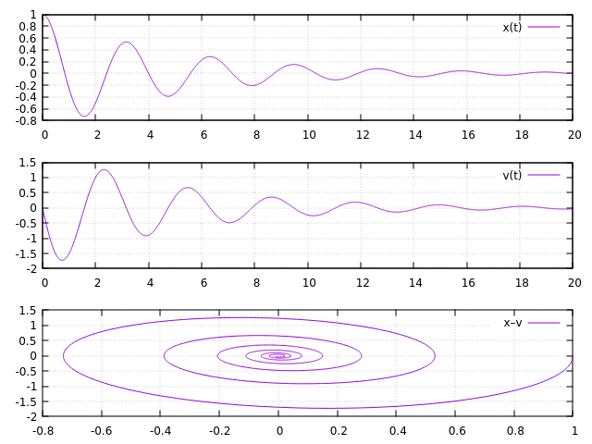
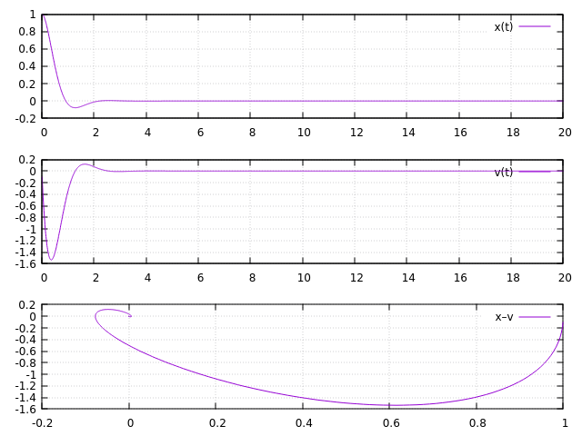
END PROGRAM DampedOscillationAnalytic
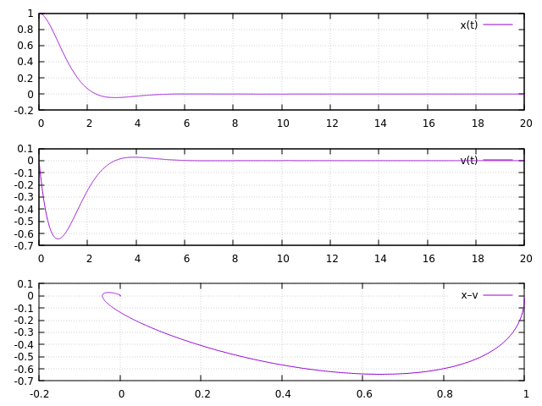

PROGRAM shm
IMPLICIT NONE

! Variables
REAL :: m, k, b
REAL :: t, x, v
REAL :: k1x, k2x, k3x, k4x
REAL :: k1v, k2v, k3v, k4v
REAL :: omega
REAL :: dt
INTEGER :: i, n
REAL :: svec(2)

OPEN(1, file='shm.dat', STATUS='REPLACE')

PRINT *, "Enter t0, x0, v0, m, k, b: "
READ(*,*) t, x, v, m, k, b

omega = SQRT(k/m)
dt = 0.01
n = 2000

DO i = 0, n

svec = S(x, v, b, omega)
k1x = svec(1)
k1v = svec(2)

svec = S(x + 0.5*dt*k1x, v + 0.5*dt*k1v, b, omega)
k2x = svec(1)
k2v = svec(2)

svec = S(x + 0.5*dt*k2x, v + 0.5*dt*k2v, b, omega)
k3x = svec(1)
k3v = svec(2)

svec = S(x + dt*k3x, v + dt*k3v, b, omega)
k4x = svec(1)
k4v = svec(2)

WRITE(1, '(F10.4, 1X, F10.4, 1X, F10.4)') t, x, v

t = t + dt
x = x + (k1x + 2.0*k2x + 2.0*k3x + k4x)*dt/6.0
v = v + (k1v + 2.0*k2v + 2.0*k3v + k4v)*dt/6.0

END DO

CLOSE(1)

CONTAINS

FUNCTION func(x, xdot, b, omega) RESULT(d2xdt2)
REAL, INTENT(IN) :: x, xdot, b, omega
REAL :: d2xdt2

d2xdt2 = -b*xdot -omega**2 * x
END FUNCTION func

FUNCTION S(x, v, b, omega) RESULT(State)
REAL, INTENT(IN) :: x, v, b, omega
REAL :: State(2)

State(1) = v
State(2) = func(x, v, b, omega)
END FUNCTION S

END PROGRAM shm


